Client Record Card

Surname |  |  |  | Forename
Address
Post Code |  | Email
Telephone |  |  |  | Mobile

Dog Details
Name |  |  | Breed
Age |  |  | Colour
Medical problems or allergies
Is the dog up to date with vaccinations
Is the dog up to date with flea/worm treatments
Behavioural issues
Vet’s name and telephone number
Special grooming requirements
Mark any lumps or warts on the body maps below, with a red cross
 |  |  | 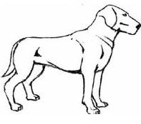

I confirm that my dog is fit and healthy. I agree that the groomer will not be held responsible for irritation due to any pre-existing skin conditions. Whilst every care has been taken to ensure that my dog will be safe, I understand that there is an element of risk involved. A risk assessment has been carried out to reduce any risk as far as possible.
I consent to veterinary treatment in an emergency should my pet’s health cause concern.

Signed ------------------------------------------------------

Print Name-------------------------------------------------

